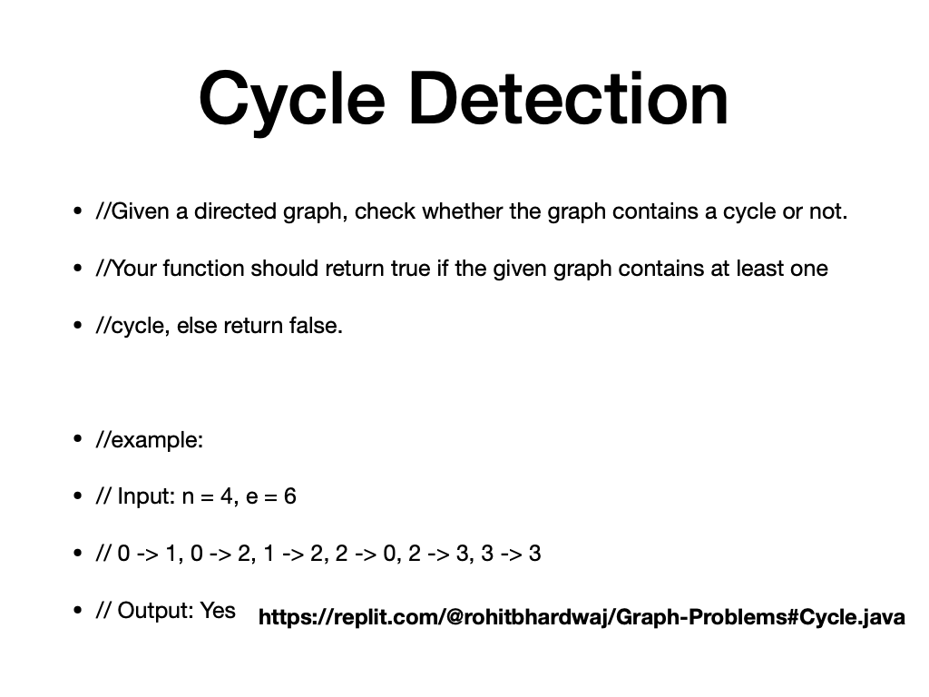

**https://replit.com/@rohitbhardwaj/Graph-Problems#Cycle.java**